**Mysticism – The Creator – Divinity**

To fear death is nothing more than to think oneself wise when one is not



For what will it profit a man to gain the whole world and lose his soul?

I Am that I Am

**Perennial Philosophy – Esotericism**

The Method of Science. The Aim of Religion.

Always have an unlimited willingness to refine your position

Approach everything with reason and equanimity

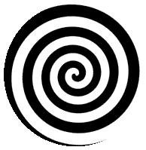

The Infinite

Gnosis - Henosis

Here is the door. Here is the key.

Know thyself. And you will be free.

**Ancient Wisdom – Hidden Knowledge**

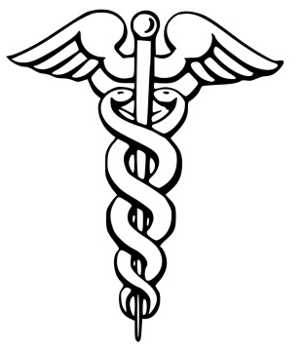 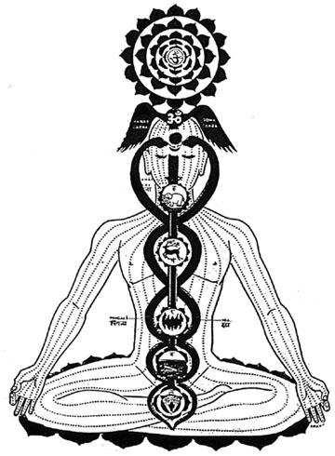

If you wish to find the secrets of the universe, think in terms of energy, frequency, and vibration.

-Nikola Tesla

The mind is a doorway. Its key is silence.

All the galaxies of the cosmos circle a gravitational singularity at their center. A single point of infinite density without volume, beyond being and non-being, existing eternally in a state of timelessness.

The blackness of the black hole is a concentration of white light being systematically absorbed once again into the One Creator. Paradoxically, the darkness of the black hole is an infinitude of light. This absorption of the ultimate spiritual gravity well continues until all the infinity of creations have attained sufficient spiritual mass in order that all form once again our great central sun, the intelligent infinity awaiting potentiation by free will. Then will be born a new universe, a new infinity, incorporating all the Creator has experienced of Itself. The cosmic heart of our Infinite Creator beats again. The journey continues. The Great Work goes on. And so it goes for eternity.

Light is an upward spiraling energy, an inevitable vector upwards toward a more comprehensive consciousness of being. Love unifies light with its source. It is the gravity of the universe that binds together all that is. With sufficient spiritual maturation and the will to seek, the will to serve, there is the self-realization of the endless continuity of consciousness. This is gnosis. This is enlightenment. This is salvation.

In truth, there is no right or wrong, there is no polarity, there is only identity, as all will be reconciled at some point in our infinite dance. All things are One. The infinite cannot be many, for many-ness is a finite concept. To have infinity you must identify or define that infinity as unity. Otherwise, the term does not have meaning. Within infinity there is only unity. There is no end to understanding, to seeking, to perception. Polarity is an alternative to understanding the complete unity of thought which binds all things. You are every thing, every being, every emotion, every event, every situation. You are unity. You are infinity. You are light. You are love. You are.

This is the Law of One.

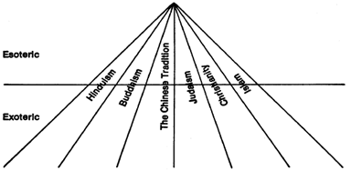

**The Law of One – The Logos**

The universe was created by the One Infinite Creator - out of itself - by distorting its energy into parts of existence called "distortions".  The process occurred one distortion at a time, in a specific order.

The first distortion created by the Creator is called Free Will. The Second is Love. The third is Light.

All other substance and form comes from an interaction of these three distortions. Akin to a hologram or a fractal, each part of the creation is also the whole.

Each galaxy is the creation of an intelligent energy called a Logos. The Logos, known as the "Word" of God, creates seven levels of progression for spiritual evolution, each of these levels a density, each density containing an infinite number of dimensions. The term density is a mathematical one, the closest analogy being that of music.

The first density is the density of the elements, with earth and water learning from fire and wind the awareness of being. This is the density of consciousness. This is the first density.

The second density is the density of organic life: bacteria, insects, plants, animals, etc, striving towards light, movement and growth. A very simplistic example being that of the leaf striving towards the source of light.

The third density is that which human beings inhabit. This is the density of self-awareness. It is also the density of duality, through which the individual chooses their polarity of service. In order to progress from third density to fourth density, individuals must make a choice between service to others or service to self: or, in ordinary language, between altruism and selfishness. The purpose of third density is to make this choice. The purpose of experiencing the sometimes harsh environment of third density is to make this choice of service and thus progress. For optimal polarization, there is a veil of forgetfulness between incarnations. Earth is now completing a third density cycle.

The fourth density is the density of love and understanding. It is not of words, unless chosen. It is no longer within the limits of possibility to cause disharmony in any way. It is a plane of compassion and understanding of the sorrows of third density. It is a plane where one is aware of the thoughts of other-selves. It is a plane striving towards wisdom or light. There are both positive and negative fourth and fifth densities. Like all subsequent densities, it is inhabited by mind/body/spirit complexes of a higher level of spiritual evolution than human beings.

The fifth density is the density of light or wisdom, wherein contemplation and introspection are learned to an even more refined degree. Like the fourth density, it is a density of intensifying rather than potentiating.

The sixth density is the density of unity consciousness, where love and wisdom are united, where all other polarities are united. This is the density of the Higher Self, or the Soul. It is analogous to the event horizon of the black hole.

The seventh density is the gateway density, the last density before mind/body/spirit complexes merge back into the Creator. The mind/body/spirit complex by its own free will has no memory, no identity, no past or future, but exists in the all. The mid-seventh density’s last action before turning towards the allness of the Creator and gaining spiritual mass is to give the resource of the Higher Self to the late sixth density mind/body/spirit complex, as a gift from its future selfness. The Logos in itself is a being, a galaxy. One ultimately becomes this being before merging back into the One Creator. This is the density of completion and the turning towards timelessness or foreverness.

The eighth density is the beginning of the next octave. Where the journey begins again.

The seven densities directly correspond to the seven primary energy centers or chakras within the human body. As above, so below. As entities evolve, they progressively balance and unblock their energy centers. Healing occurs when a mind/body/spirit complex realizes, deep within itself, the intelligent infinity resting within, the awareness of the Creator as self. It requires the conscious awareness of the spiritual nature of reality, and the corresponding pourings of this reality into the individual mind/body/spirit complex for healing to take place. The proper balance of the energy channels will allow the energy influx of intelligent infinity to flow through the healer. The healing ability is effected by the opening of a shuttle or gateway to intelligent infinity. Hinduism refers to this as Kundalini.

Any portion, no matter how small, of any density or illusory pattern contains, as in a holographic picture, the One Creator which is infinity. Thus all begins and ends in mystery.

**The White Magician – The Mystic – The Bodhisattva**

The white magician radiates his intention for the highest good. He transforms his shadow and fears by accepting them. He stands behind his decisions. Never does he influence other people's life, unless they ask. His tools are silent knowledge and intent. His way is the way of the heart. Wherever he goes, he enhances life energy and light.

The universe is mental, existing within the mind of the Creator, the divine mind, the Logos. The paradox that everything came from nothing is resolved by recognizing this. For the only way something can be created from nothing is mentally, as in doing so one uses no outside materials but yet their spirit pervades the creation. The Creator is the essence of all that is. The cosmos being an ocean of energy vibrating at unique frequencies. All material is made of immaterial. Molecules and atoms are made up of metaphysical quarks and photons. The movement of celestial bodies - the Sun, Moon, and planets - can be seen as a form of music within a sea of harmonic vibrations. The Creator is the ultimate source of all vibration. It is alpha and omega.

While All is in The All, it is equally true that The All is in All. To him who truly understands this truth hath come great knowledge. As each part of the creation contains the whole, within each being is the infinite universe.

Focus - Spirituality, Love, Wisdom, Knowledge, Unity, Compassion, Kindness, Intelligence, Honesty, Virtue, Empathy, Morality, Integrity, Courage, Humility, Forgiveness, Will Power, Freedom, Equanimity, Creativity, Intuition, Imagination, Beauty, Silence, Truth, Self-Awareness, Happiness, Selflessness, Oneness, The Good

Wisdom - Mysticism, Divinity, the Infinite, the Soul, True Will, Service to Others, Altruism, Mental Alchemy, Higher Consciousness, Energy, Vibration, Perception, Words, Philosophy, Enlightenment, Divination, Kundalini, Seven Seals, Gnosis, Microcosmology, Purity, Duality, Good and Evil, Transmutation, the Divine Mind, the Logos

Knowledge - Emanationism, Esotericism, Henosis, the Monad, White Magic, the Great Work, the Philosopher's Stone, Occultism, Ancient Wisdom, Esoteric Cosmology, Theosophy, Perennial Philosophy, the Void, Pantheism, Hermeticism, Monism, Buddhism, Hinduism, Taoism, Stoicism, Esoteric Christianity, Kenosis, Theosis, Theurgy, Zoroastrianism, Anthroposophy, Thelema, Sophia, Ancient Greece, Ancient Egypt, Astrology, Kabbalah, Ein Sof, The All, Plotinus, the One, Prana, Chi, Bodhisattva, Dandamis, Tarot, Sacred Geometry, Chakra Alignment, Rigpa, Holism, Reincarnation, Brahman, Cosmic Humor, Timelessness, Consciousness, Higher Self, Intelligent Infinity

Obstacles - Arrogance, Ignorance, Materialism, Negativity, Immorality, Egotism, Dishonesty, Shallowness, Envy, Wickedness, Greed, Pride, Narcissism, Selfishness, Hypocrisy, Closed-Mindedness, Power, Fame, Decadence, Doubt, Worry, Unworthiness, Ingratitude, Cultural Hegemony, Television, Media, the News, the Past, Money

Money makes one spiritually blind. A diamond holds no more value than a glass of water. One sacrifices morality, rationalizes selfishness, and justifies unethical behavior in the name of an artificial system of value. Greed is desiring much more than you need. It is a bottomless pit which exhausts the person in an endless effort to satisfy desires without ever reaching satisfaction. One confuses happiness, a metaphysical state of mind, with their external environment and the possession of physical material. The physical world is a manifestation of lower vibration. You are your thoughts. The only time it will ever be is now. Things only have value if one gives them value. Step outside of the collective consciousness. Bring the unconscious into your awareness. Pierce the illusion. You are not your body. You are consciousness itself. You are infinity. The turning away from the simple shall slay the wicked. The prosperity of fools shall destroy them. All the gold in the world will not buy you wisdom. Wisdom is salvation.

You are a non-physical consciousness experiencing physical reality. Change is the only constant. While you may change form, you cannot cease to exist. The only cure for ignorance is the pursuit of knowledge.

Truly I tell you, the kingdom of God is within you. Be the light of the world. Light up the darkness. Free yourself from illusion and ignorance. Be love and wisdom. Solve paradoxes and unite opposites. Do not love gold nor fear death. Focus your free will on love and you shall become en"light"ened. The mind may be opened like a door. The key is silence. Keep mental clarity. Focus on The Good. Even the wicked love their friends. Love your enemies. Love is the law. Love under will. Overcome your fears and desires and seek wisdom and understanding. Seek and you shall find. Free yourself from sensory desire. Meditate. Attach not to the things of this world. Surrender. Conquer deception. Understand why things are the way they are. Seek wisdom. All the things that may be desired are not to be compared to it. Transcend. Polarize your consciousness. Place the mind in the heart. Embrace mystery. Contemplate existence. Ponder infinity. Free your mind. Become One with the Creator. Seek within. Know thyself.

**Hermetic Magic – Divinization – Kundalini**

The Method of Science, the Aim of Religion.

Good thoughts, Good words, Good deeds. As above, so below.

Three parts of the wisdom of the whole universe. Alchemy – Astrology – Theurgy

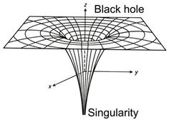

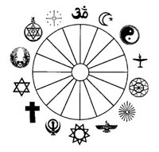



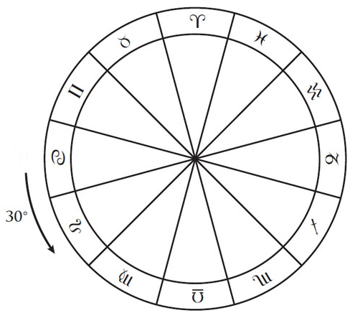

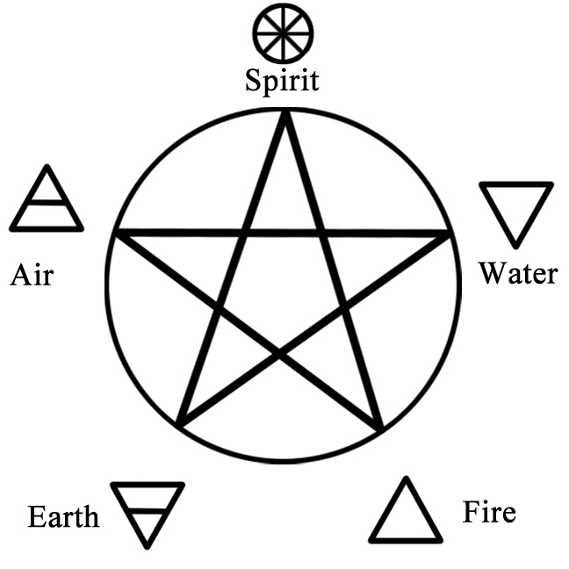

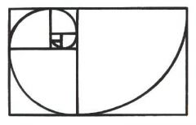

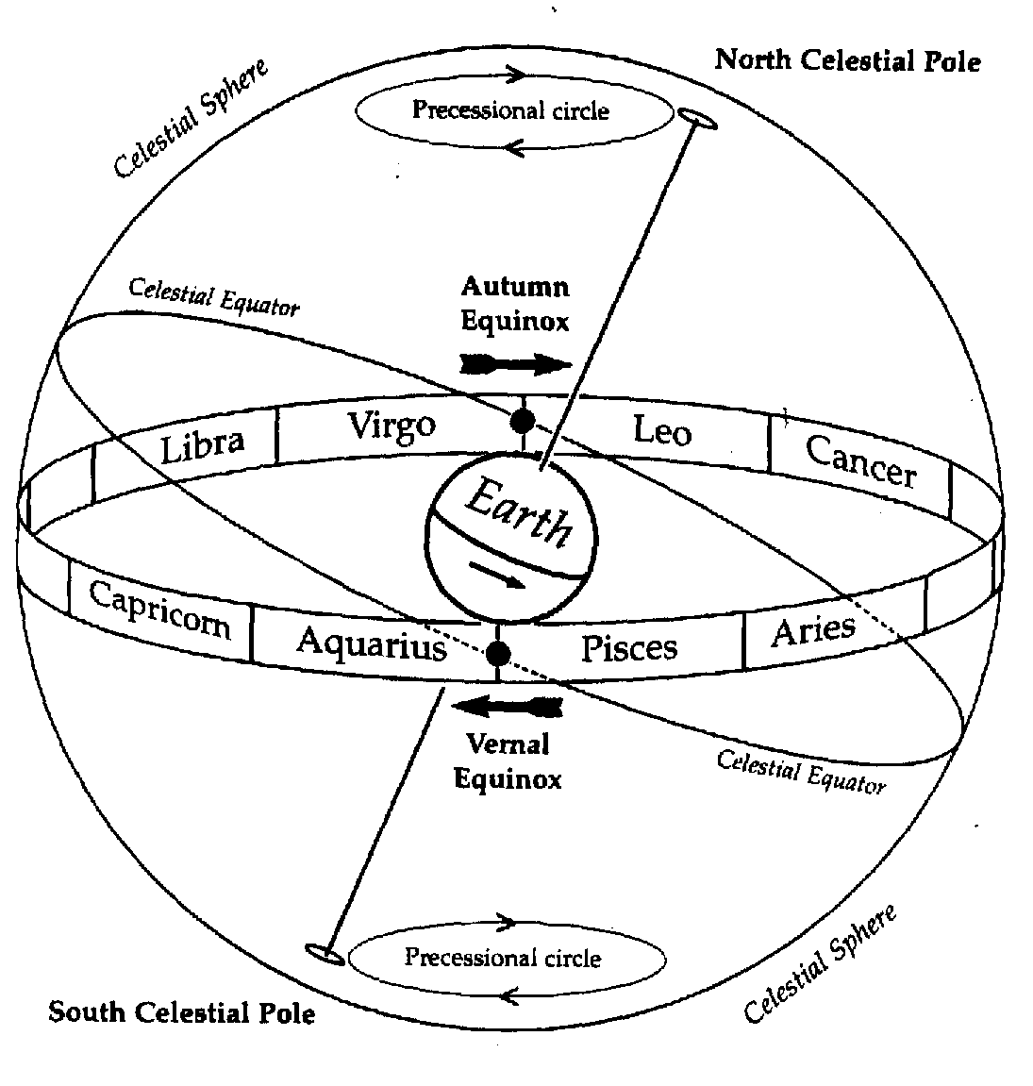

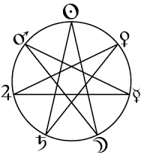

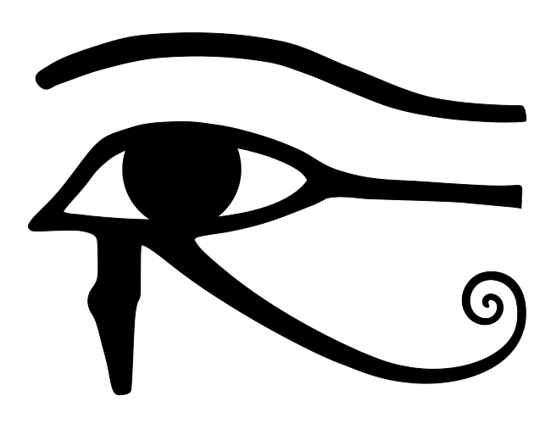

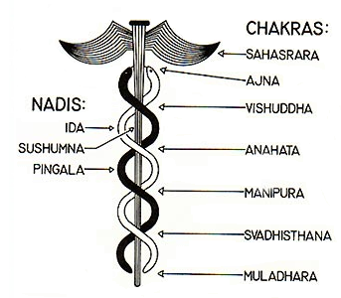

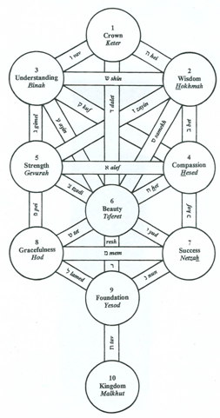



*Concerning matter, we have all been wrong. What we call matter is energy, whose vibration has been so lowered as to be perceptible to the senses. There is no matter.*

-Albert Einstein

**The Key to the Kingdom – The Seven Seals**

One may penetrate the eighth level from the opening up of the seventh through the sixth.

The opening of the fourth springboards you to the fifth.

The opening of the seventh must be done through the sixth.

Love is the law. Love under will.

As above

The Creator – Intelligent Infinity – Faith – The Octave

The Logos:

Seventh Density – Oneness – Pure Awareness – All That Is – World of Emanation

The Flow of Consciousness

Sixth Density – Higher Self – Unity – Seat of the Soul – World of Creation

Fifth Density – Light – Wisdom – World of Form

Fourth Density – Love – Understanding – World of Action – "Heaven"

Third Density – Duality – Self-Awareness – Material World

Second Density – Growth – Movement – Material World

First Density – Elements – Awareness – Material World

So below

Third Density:

(Violet) Seventh Chakra – Sahasrara – Gateway – Selflessness – Detachment from Illusion (Fixed)

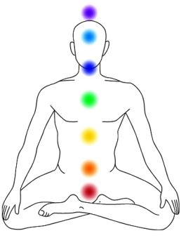

(Indigo) Sixth Chakra – Ajna – Third Eye – Intuition – Spirituality

(Blue) Fifth Chakra – Vishuddha – Wisdom – Communication

(Green) Fourth Chakra – Anahata – Universal Love – Compassion – Altruism

(Yellow)Third Chakra – Manipura – Self-Awareness – Polarity – Ego

(Orange) Second Chakra – Svadhisthana – Unconscious – Emotion – Sexuality

(Red) First Chakra – Muladhara – Foundation – Instinctual – Survival (Fixed)

Unite with the Absolute. Become One with the Creator.

The universe is mental. All is mind.

*The true sign of intelligence is not knowledge but imagination. Imagination is more important than knowledge. Knowledge is limited, imagination encircles the world.*

*-*Albert Einstein

**Dzogchen – Rigpa – The Rainbow Body**

The Evolution of Consciousness - The Seven Densities - The Logos

The Fundamental Ground - The Primordial state of the Absolute - Pure Awareness

Purity (Emptiness) - Clear Light (Spontaneous Presence) - Compassionate Energy

**5**

**4**

**6**

**3**

**2**

**1**

**Infinity - The Creator - The Absolute - The Source - The Singularity**

**2.Bacteria/Plants/Animals - Growth - Movement - Unconscious - Emotions**

**3. Human Beings - Self-Consciousness - Duality - Polarity - Ego - Physical World**

**The Milky Way Galaxy**

**7**

**7. Gateway - Oneness - Selflessness - All That Is - Pure Awareness - World of Emanation - The Black Hole - The Gravity Well - Divinity Plane**

**6. Unity - Love/Light - Wisdom/Understanding - The Higher Self - The Soul - World of Creation - The Event Horizon - Spiritual Plane**

**5. Wisdom - Light - Communication - World of Form - Mental Plane**

**4. Love - Understanding - Compassion - Altruism - World of Action - "Heaven" - Astral Plane**

**1. Elements/Minerals - Foundation - Vitality - Consciousness**

**Higher Consciousness – Alchemy – The Trinity**

Hermeticism - The three parts of the wisdom of the whole universe

Alchemy - Astrology - Theurgy

 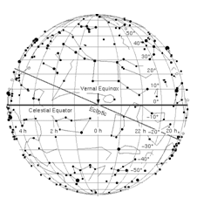

**Astrology Father**

*Macrocosm*



**Holy Spirit**

*Consciousness/Intellect*

**Theurgy**

*Union*

*Microcosm*

**Alchemy Son**

*Ajna - Third Eye - Pineal Gland*

*Raise Your Consciousness*

 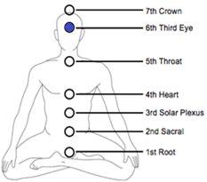

"The lamp of the body is the eye. If therefore thine eye be single, thy whole body shall be full of light."

"It is easier for a camel to go through the eye of a needle than for one who is rich to enter the kingdom of God."

"I tell you the truth, unless you change and become like little children, you will never enter the kingdom of heaven. Therefore whoever humbles himself like a child is the greatest in the kingdom of heaven."

**Oneness – Happiness – Consciousness**

The Infinite Creator:

Free Will

Love

Light

Four fundamental forces of the cosmos:

Strong Force - Internal World - Spiritual - Higher Vibration - Thought - True Will

Weak Force - External World - Physical - Lower Vibration - Senses - False Self

Gravitational Force - Love

Electromagnetic Force - Light

All insides have outsides. All outsides have insides.

Love is the law. Love under will.

Light up the darkness. Use the force.

As a microcosm of the macrocosm, the mimicking of the Logos unites one with the Creator. The reversing of the ontological process of consciousness via meditation and emanationism toward no thought and no division allows one to form a union with the Creator, providing the awareness of the nondualistic and spiritual nature of reality.

Consciousness vibrates on a higher level than the physical mind. Thoughts are non-physical. Our senses along with the physical world are tuned to a frequency, as a radio to a station. The external world serves as a mirror of the internal. It is the reflection of a collective stream of thoughts. Consciousness receives input from neurotransmitters, the senses. The only thing that ever "dies" is the body, the senses. Consciousness is eternal. One who is able to face their fears, conquer duality, let go of the ego and surrender their false conception of "I" shall not experience death. He will be One with the divine, being fully aware of the illusion and progressing toward a more comprehensive consciousness of being. He that overcometh shall inherit all things.

We incarnate and progressively open and balance our energy centers, or chakras, which are the mysterious source of human consciousness. Between incarnations we review the past experience from a higher perspective of the Logos and perceive the imbalances within ourselves. Tibetan Buddhism refers to this as the Bardo. It is not possible to correct any unbalanced actions between incarnations but rather to perceive the imbalances and forgive the self. While incarnated, working in darkness with only a candle, one may correct the imbalances.

Activation of the seven energy centers is the mastery of few. In order to progress to the next level of consciousness, one must consciously make a choice between service to self or service to others, between selfishness and altruism. There are both positive and negative fourth and fifth densities, equating to what we may term Heaven and Hell. The majority of people lack the self-awareness and spiritual evolution necessary to make this choice and will repeat third density. If one wishes to enter the realm of everlasting cosmic equality, one must act heavenly and have a great deal of compassion for others. One must purify their mind of greed, shallowness, and self serving intentions.

The Golden Rule - Love thy neighbor as thyself

True human happiness is the effective use of the most authentic human capacity of contemplation. The true human being is an incorporeal contemplative capacity of the soul and is superior to all things corporeal. Genuine human happiness is dependent on metaphysical concepts found in the highest capacity of reason, allowing one to identify with that which is best in the universe. One who is truly happy is not effected by external circumstance.

Cosmic Humor - Most human beings don't believe in the spiritual for lack of proof, yet thoughts are spiritual and consciousness does not objectively exist.

**Simplicity – The Golden Age – Fourth Density**

Divinity



Light

Consciousness/Intellect

Darkness

You

Enlightenment can only occur by the self, for the self.

Service to Others - an energy center configuration where the green-ray center radiates out toward other beings. This results in compassion, feelings of love, and acts of service toward others.

Service to Self - an energy center configuration where the green-ray center is pointed mainly inward. This configuration causes an entity to feel love for itself, but not for others. These feelings lead to self-serving intentions and actions, or service to self.

The Earth is a living being with a mind, free will, and grows over time both physically and spiritually. Earth is currently in the process of changing from a third density to a fourth density planet.

Fourth density positive entities will remain on Earth, but on a higher plane of existence, ushering in the perceived Golden Age. Fourth density negative entities will be relocated to another planet. The great majority of the Earth's inhabitants will repeat the third density cycle in another part of the galaxy to undergo further spiritual evolution.

In a moment, in the twinkling of an eye, we shall be changed. (Hint - The Photon Belt)

Blessed be the poor. For yours is the kingdom of God.

Blessed are you who hunger now, for you shall be filled.

Blessed are you who weep now, for you shall laugh.

But woe to you who are rich! For you have received your consolation.

Woe to you that are full, for you shall hunger.

Woe to you that laugh now, for you shall mourn and weep.

**Equilibrium – The Great Work – Immortality**



The Flow of Consciousness

Pingala - Masculine - Value placed on self

Ida - Feminine - Value placed on others

Sushumna - Equilibrium - Kundalini - Self is other-Self

The opening of the seventh is accomplished through the balancing of the sixth, allowing one to be truly free from illusion and the realization that Self is other-Self.

The Golden Rule - Love thy neighbor as thyself

All is One and that One is the Infinite Creator.

**Who are you? What are you? Why are you?**

- Know thyself -

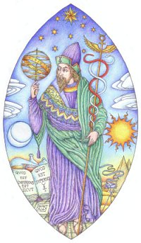

*Trismegistus*

Knock … and it shall be opened to you

Seek … and you shall find!

Pay no attention to the opinions of the multitude. The blind lead the blind.

Magical Tools – True Will, Faith, Unconditional Love

There is a driving force more powerful than steam, electricity, and atomic energy. The Will.

-Albert Einstein

**The Mystery of the Woman**

"I will tell thee the mystery of the woman, and of the beast that carrieth her, which hath the seven heads and ten horns.

The beast that thou sawest was, and is not; and shall ascend out of the bottomless pit, and go into perdition: and they that dwell on the earth shall wonder, whose names were not written in the book of life from the foundation of the world, when they behold the beast that was, and is not, and yet is.

And here is the mind which hath wisdom.

The seven heads are seven mountains, on which the woman sitteth.

There are seven kings: five are fallen, and one is, and the other is not yet come;

and when he cometh, he must continue a short space.

And the beast that was, and is not, even he is the eighth, and is of the seven, and goeth into perdition

And the ten horns which thou sawest are ten kings, which have received no kingdom as yet; but receive power as kings one hour with the beast.

These have one mind, and shall give their power and strength unto the beast.

These shall make war with the Lamb, and the Lamb shall overcome them: for he is Lord of lords, and King of kings: and they that are with him *are* called, and chosen, and faithful."





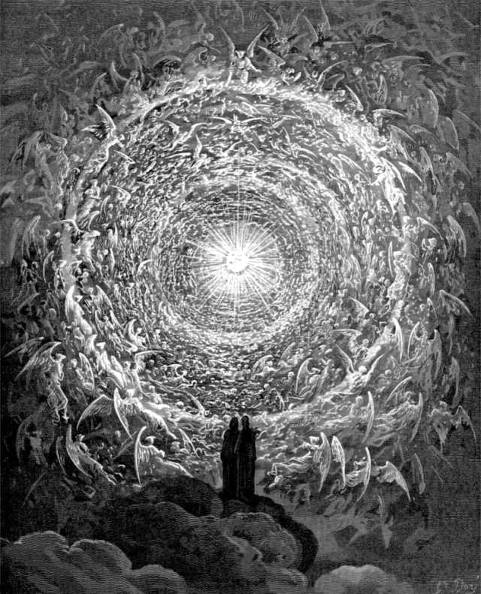

"Thou sayest, 'I am rich; I have acquired wealth and do not need a thing.' But you do not realize that you are wretched, miserable, poor, blind and naked."